GIT Version control/Manage it will be available in Local Machine
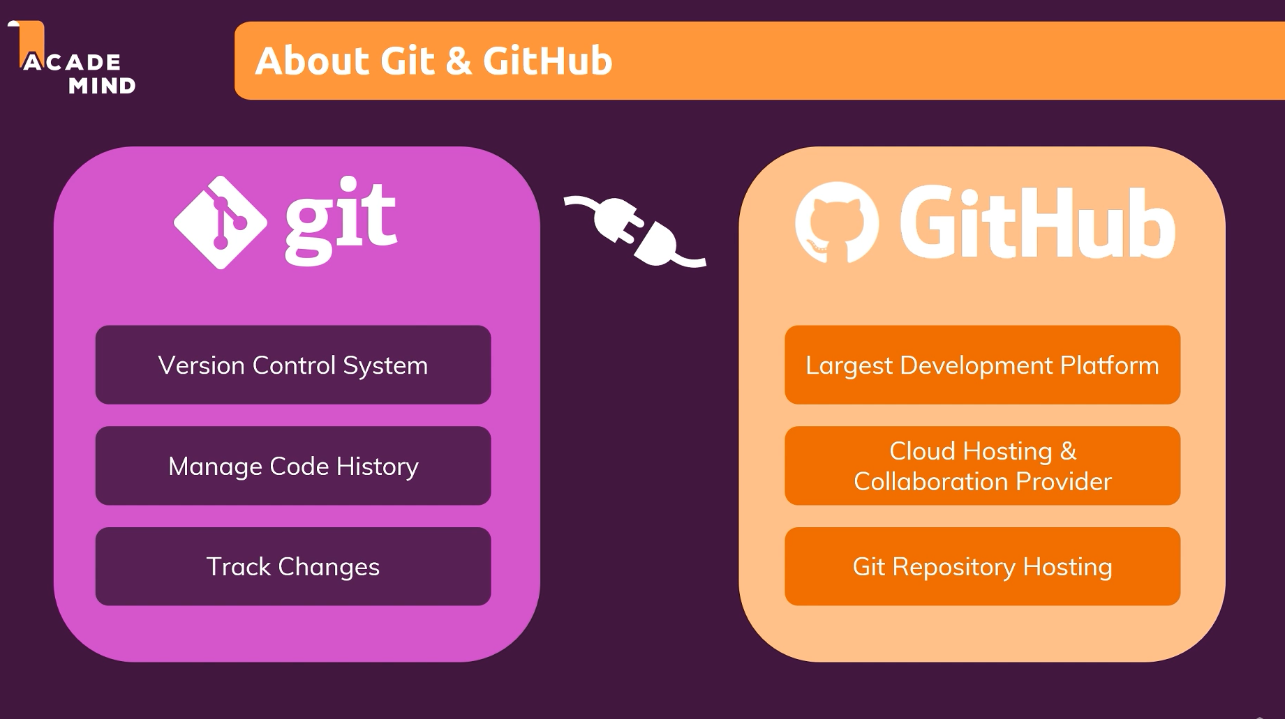


Windows Command prompt
Mac Z Shell

Commands:
Cd Change Directory(present working directory it will print)
Dir Directory List
mkdir Make Directory
rmdir remove directory
echo (<filecontent>) > (<filename>.<fileextension>) it will create file with the text
ex: echo datainside the file > newfile.txt

type <filename> it will print the text inside the file
del <filename> it will delete the file
copy <filename> <path>
move <filename><path>

Windows Command Prompt overview => https://docs.microsoft.com/en-us/windows-server/administration/windows-commands/windows-commands
---
The "new" Windows Powershell (not used in the course) => https://docs.microsoft.com/en-us/powershell/scripting/overview?view=powershell-7

All commit details will store in Branches (master branch/Main Branch)

Terminology:
Working directory it contains one project file, that project file managed by git
Commit

Add (staging) Commit
Git log (All commit information it will give)

A detached HEAD in Git means that you are not on a branch but instead directly on a specific commit. Normally, when you work in Git, you are on a branch (like main or feature-branch). But if you check out a specific commit instead of a branch, Git puts you in a detached HEAD state.

Git switch <branchName> git checkout <branchName>
Git switch -c <branchName> git checkout -b <branchName>

if we want to undo the unstaged changes, then below commands we need to use

Git restore <specific filename with extension> git checkout < specific filename with extension>
Gir restore . git checkout .
Git clean -df it will delete the untracked files(directories)
-df delete forcely

Undoing Staged Changed:

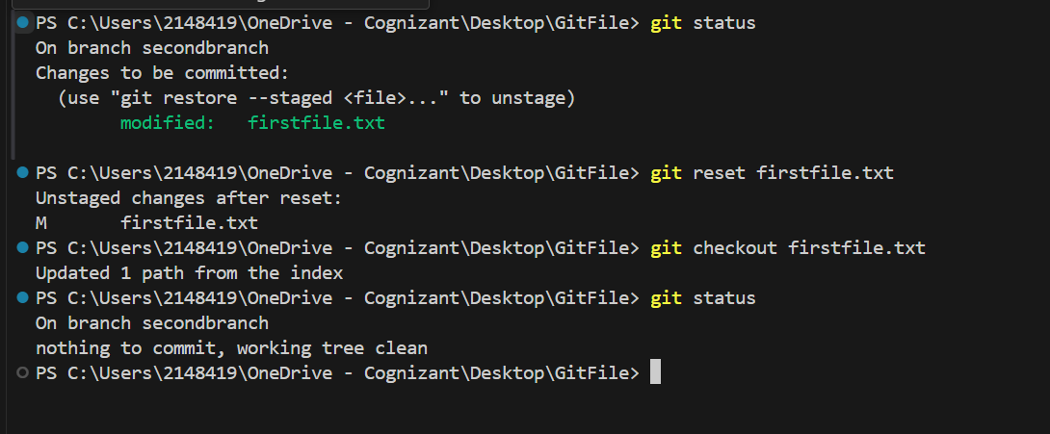

Git reset <filename with extension> this will change that file from staged to unstaged
Git checkout <filename with extension> this will remove the unstaged changes

2nd way :
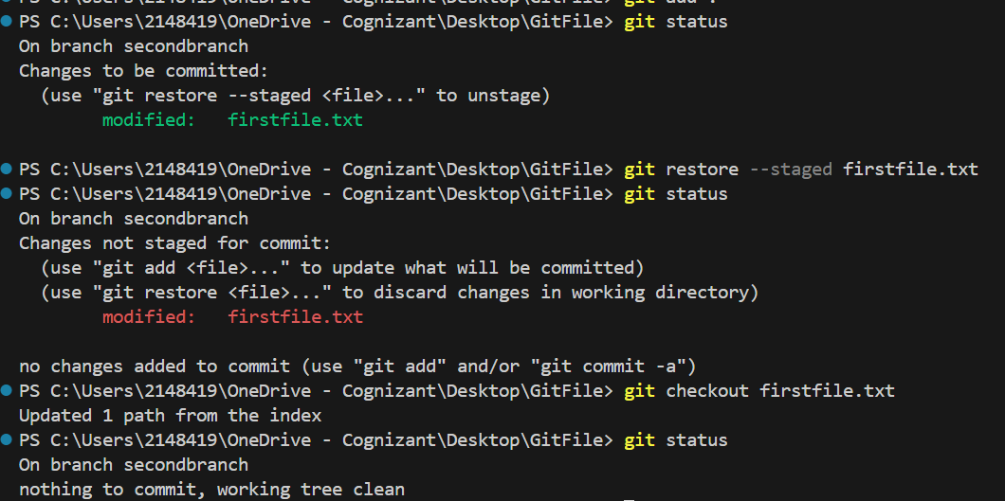
Git restore --staged <filename with extension> this will change that file from staged to unstaged
Git checkout <filename with extension>
Reset :
For deleting committed data we need to use below commands:
Git reset --soft Head~1 it will delete the commit but that change will be available in staging area

Git reset Head~1 it will delete the commit and change to unstaged

Git reset --Hard Head~1 it will delete the commit and remove the changes(that changes also will delete)

Head~1 latest first commit alone it will take
Head~2 latest two commits it will consider

Git branch -d <branchName> or git branch -D <branchName>

-D will delete the branch forcely

Git branch -D <branch Name1> <branch Name2>

Committing detached Head

Git checkout <detachedHeadid>
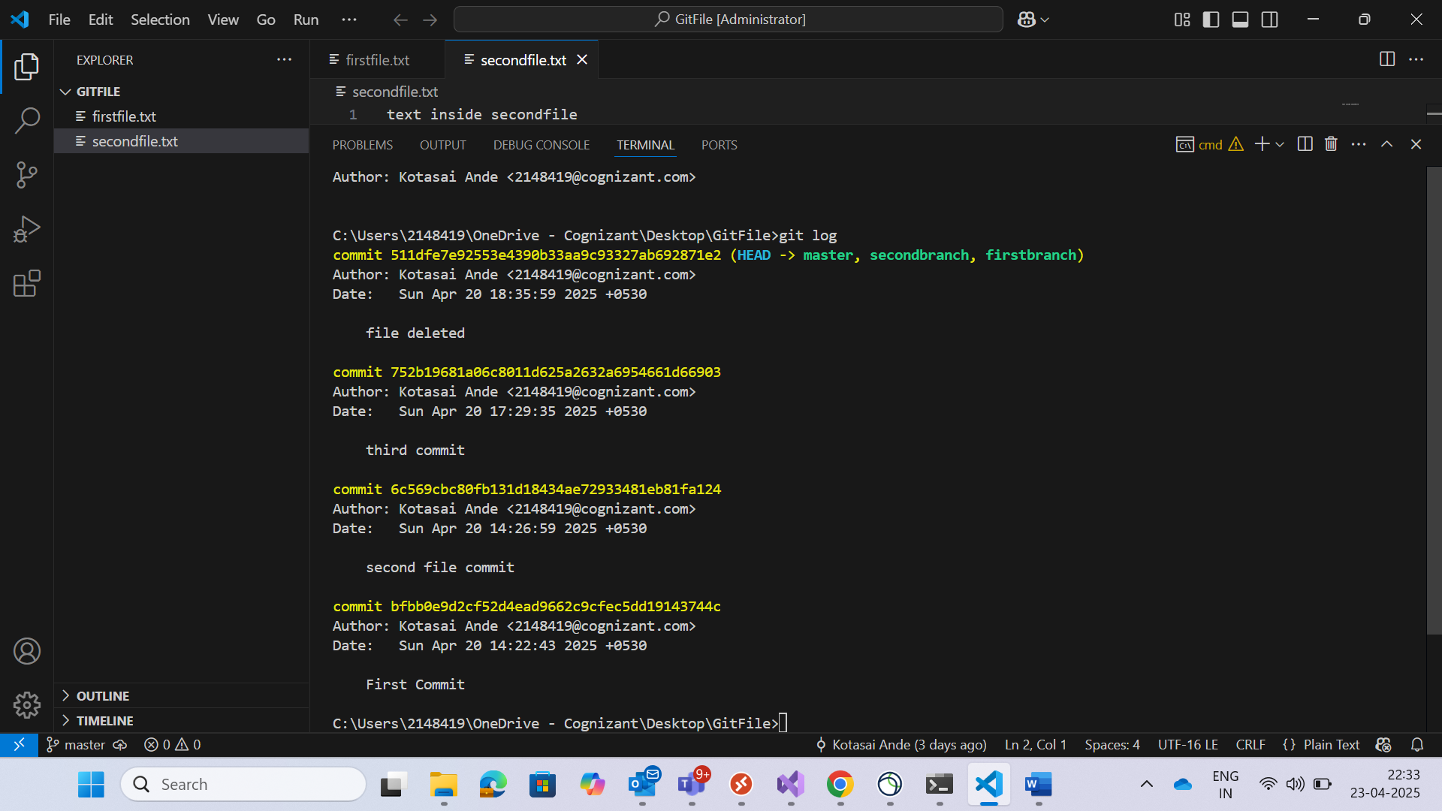
These 3 are called detached Heads, because Head will point to latest commit only. So previous commits we are called as detached commits

So if we want to check out to any detached head, then we need to use below command
Once checkout to the detached head after completing the changes and committing the stages, if you create new branch then that detached commit replication branch will create
Git checkout <detachedHeadCommitid>
Git branch <branchName>

After checkout to detachedheadcommit if you create any branch, then that detachedHead replicate branch will create.
git branch <new-branch-name> 600f207

600f207 detachedHeadId
6c569cbc80fb131d18434ae72933481eb81fa124 detachedHead commit

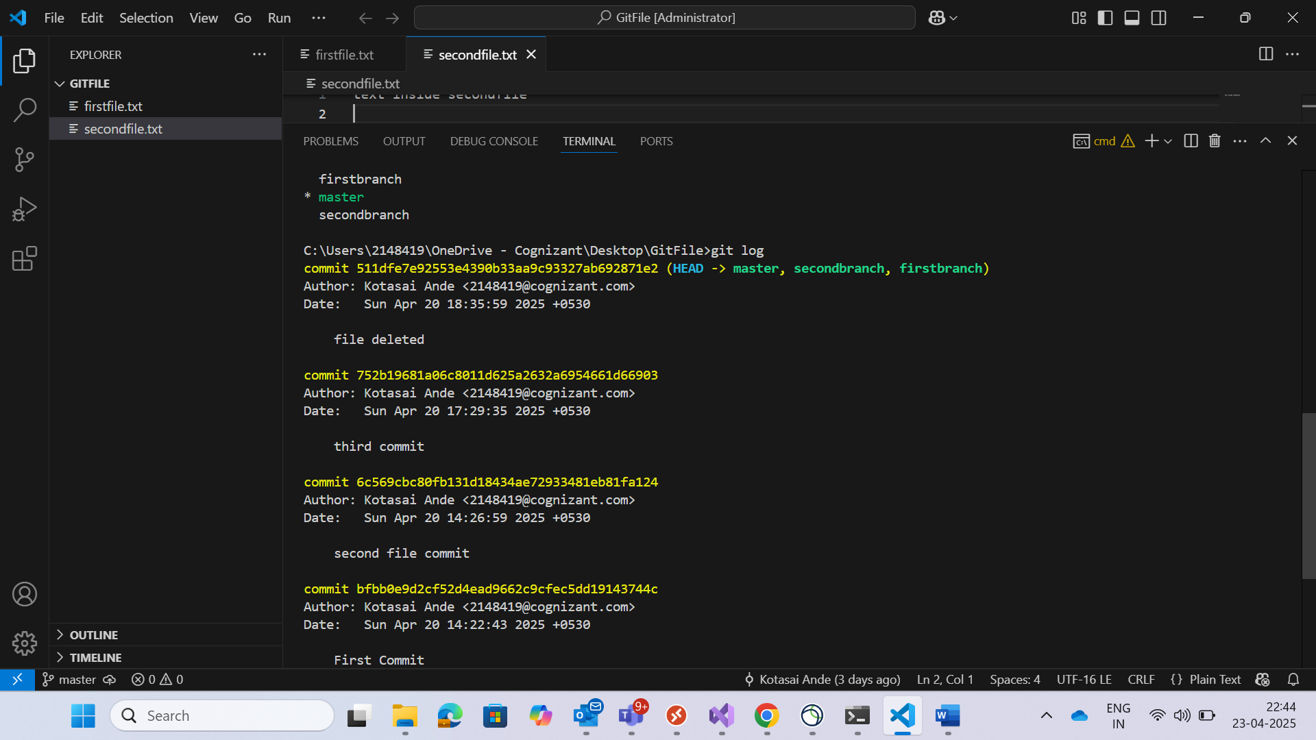

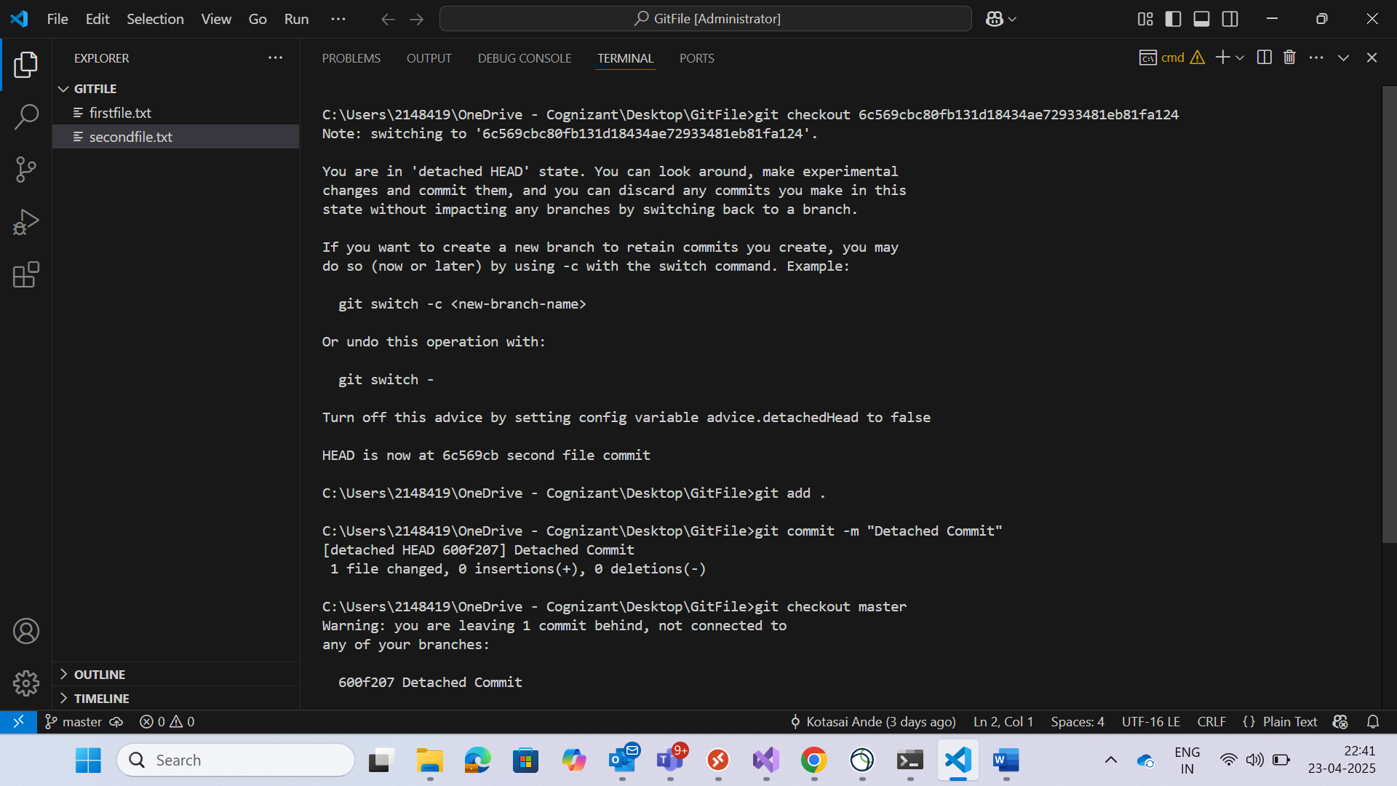

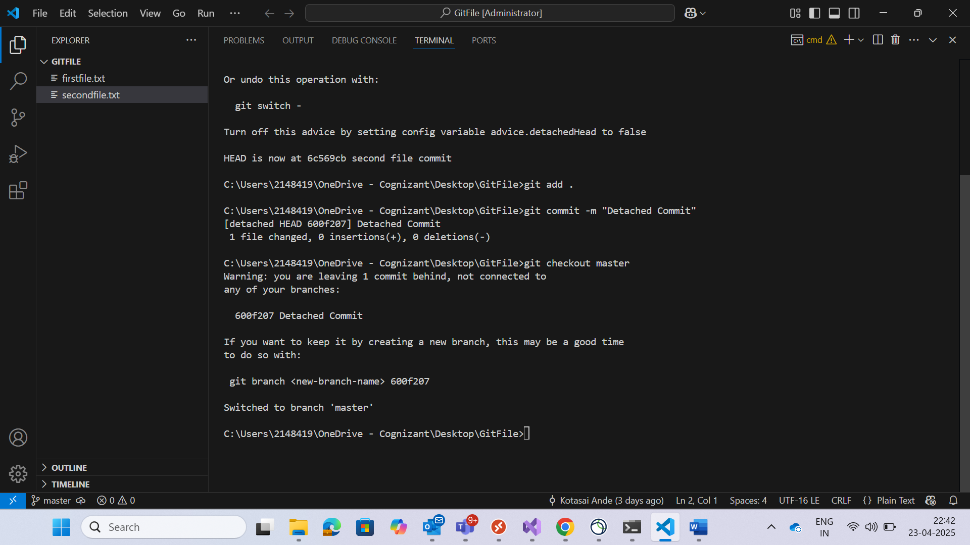

Gitignore this file is useful for ignoring the files to tracking purpose. So if we have changes in mentioned files in git ignore, git will not track the changes

.gitignore
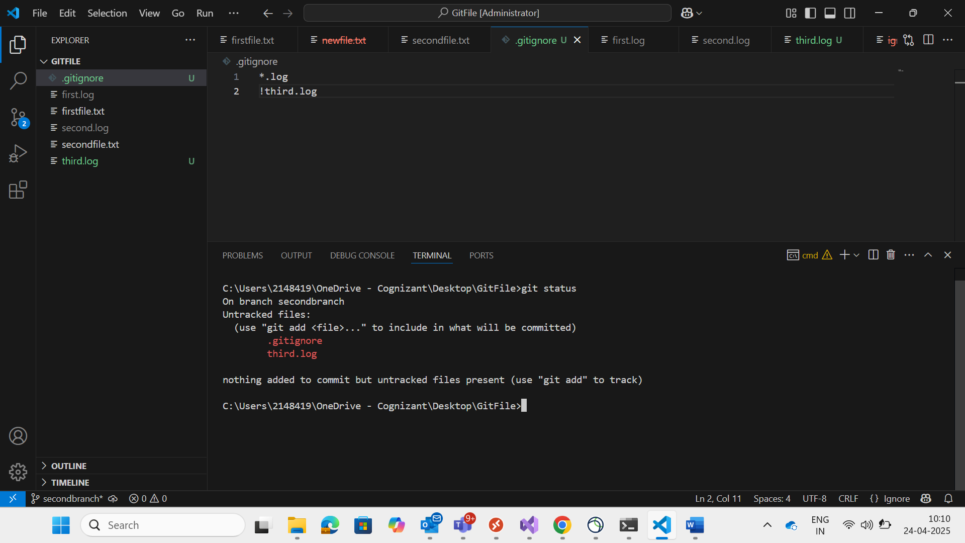

*.log this will ignore files contains extension as .log
!third.log here symbol (!) meaning is no need to ignore that file changes. That means that changes git will track

In Above mentioned screenshot git tracking changes for third.log and .gitignore. but remaining other files extension with .log is not tracking.

Git stashing:

ACDP
A Apply , C Clean , D Drop , P Pop
Git stash it will stash the staged changes
Git stash -m “<some msg>”
Git stash show
Git stash Apply 0 revert back the stashed changes
0 stash index value

Git stash drop 0 it will drop that stash
Git stash clean it will remove all stashes
Git stash pop 0 it will revert the changes back and remove from stashing

Reflog ref log is used to bring back lost commit and branches

Git reflog it will give past history loggs

Fast Farward Merge
Git merge <branchName>
Git merge --squash <branchName> this will merge the changes to staging area in target branch. So again we need to commit the changes in target branch

Master
M2
M2
M1

Feature
F2
F1
M1
M2

Non Fast forward recursive strategy:

We have two files(M1,M2) in Master branch, after creating new branch(feature) we have created one more file(M3) in master branch and same way we have created two files (F1,F2) in feature branch . so hear we have changes both branches.in this case we cant proceed with ‘Fast forward’.

git checkout master
git merge feature using this command we can merge the all the commits to master branch and along with existing commits in ‘Non-fast forward’ one more commit will add. That commit contains feature branch changes (F1,F2)

Rebase:
Rebase also same like non-fast forward strategy, but here new commit will not come. But it will merge the changes with new commitid’s
Git checkout feature
Git rebase master here using rebase we are merging the master branch changes to the feature branch

Git merge --abort if we have any merge conflict for unmerging the changes we will use this command
git status, git diff these commands useful for knowing the conflict

git cherry-pick <commitid> if you want to merge the particular commit then using this command we can do. Like in feature branch you have done changes in ‘F2” file and committed, after that new file (F3) created and again committed. So here if you want to merge F2 change alone, then you can copy the commitid and merge that changes. But here after merging that particular change it will show different commitid. That means in master branch that commitid copy will create.

Tags:
1.Light weight Tags
2.Annotation tags
Git tag <version> <commitid>
Ex: git tag 1.0 <commitid>

Git tag it will show the tag list

Git show <tag> it will show the detailed tag information
Ex: git show 1.0

Git tag -d <version> it will delete the tag

Git log --oneline --all

From Local to remote understanding Module

git branch it will give local branches

Master branch in local machine
Remote/origin/master repository tracking branch, this also in our local machine but its copy of remote branch

Master Remote Branch

Git branch -a this will give all branches(local branch ,remote tracking branch, remote branch)
Git branch -r it will give remote tracking branches alone

Git branch -vv it will show details information of git branch and commit
Git branch --track <new branch> <tracking repository branch>
Git ls-remote using this command we can send the call to git remote repo and will git the all branches created/available inside the repo

Git branch -D <branchName> deleting branch in our local repository
Git branch --delete --remote origin/<branchname> it will delete the branch in tracking repository

Git push origin --delete <branchname> this will delete the branch from remote repo
Git ls-remote
Git push origin <branchName> it will push the data to repo to that mentioned branch . if that branch is not available then it will create in remote repo and push the code to remote repo.
Ex: git push origin feature2

Collaboration Part of the project
Contribution not part of project but work in open source

There are 3 types of accounts
1.Personal Account
2.Organizational Account
3.Enterprice account

